Locum Staff User Guide

Overview
This manual provides step-by-step instructions for dental professionals to register as locum staff on the platform. The registration process allows dental nurses, hygienists, and other professionals to connect with dental practices seeking temporary or locum staff.

Registration Process

Step 1: Access Registration Page
- Navigate to the platform homepage
- Click on "Register" in the top navigation menu

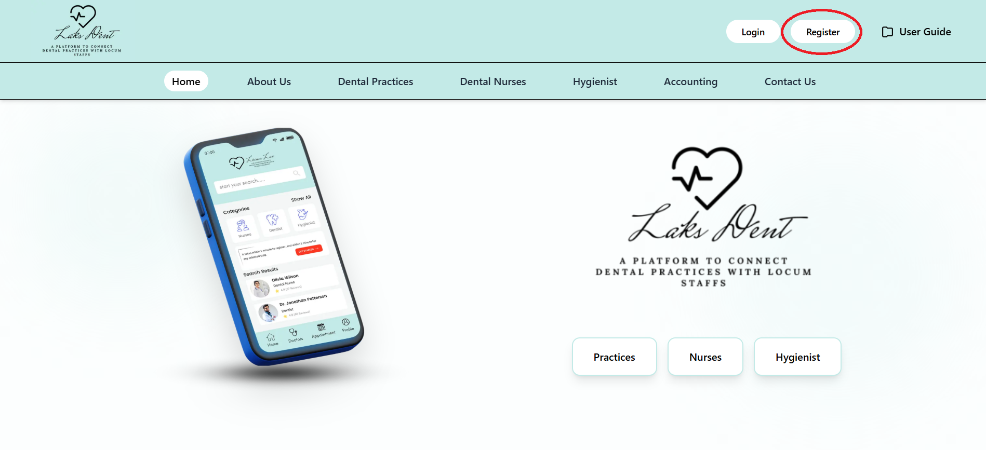

- Select "Locum Staff" as your registration type

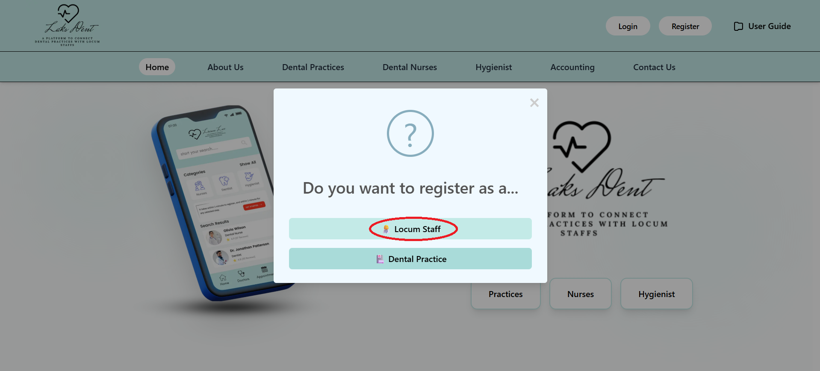

Step 2: Complete Registration Form

Personal Information Section
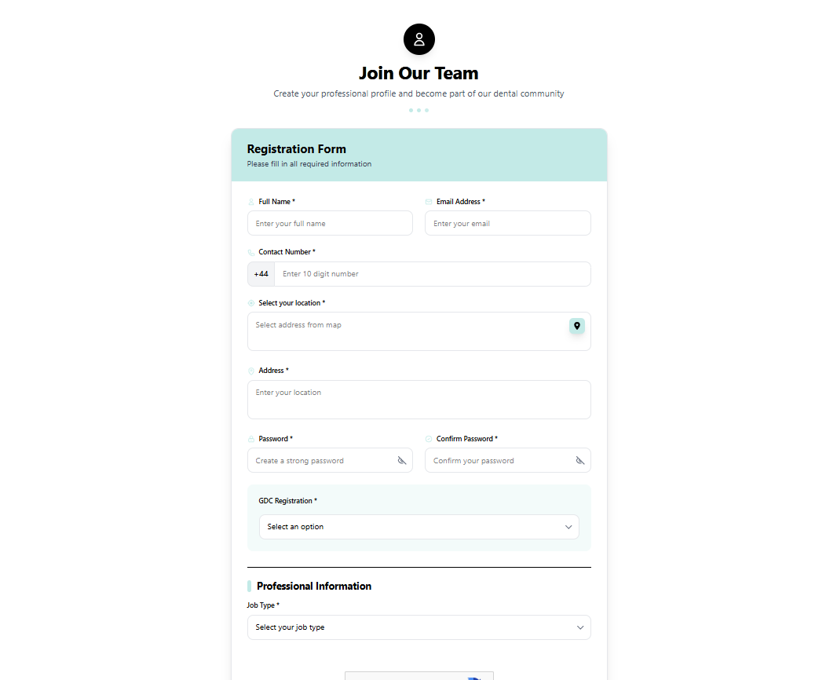

Name: Enter your full legal name
Email Address: Enter your professional email address

Contact Number: Provide your contact number (10-digit format)

Select your location: You must select your location using the map icon
- Click the map icon next to the select your location field

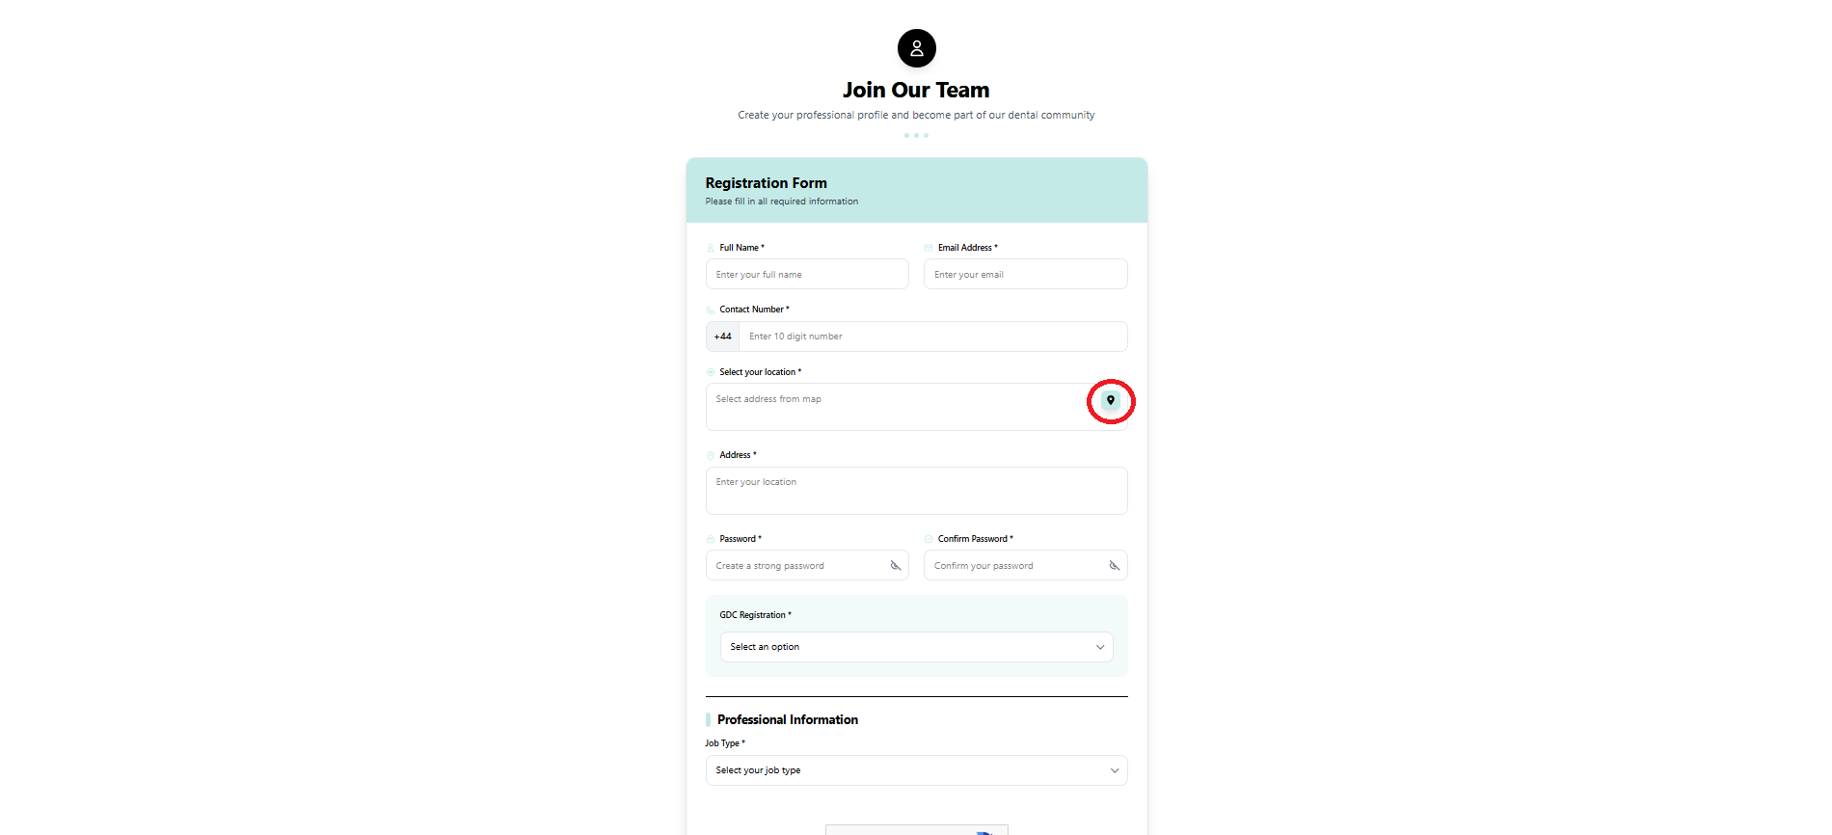

- A map interface will open
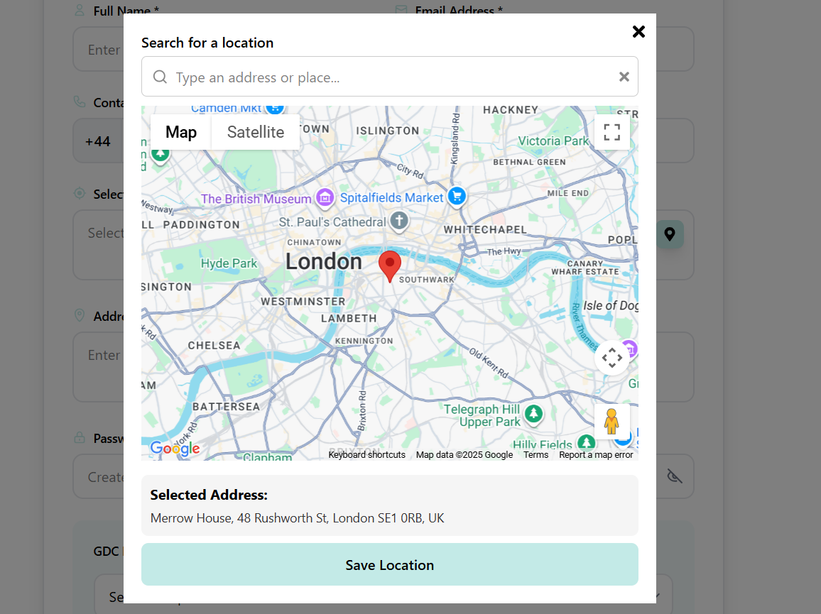
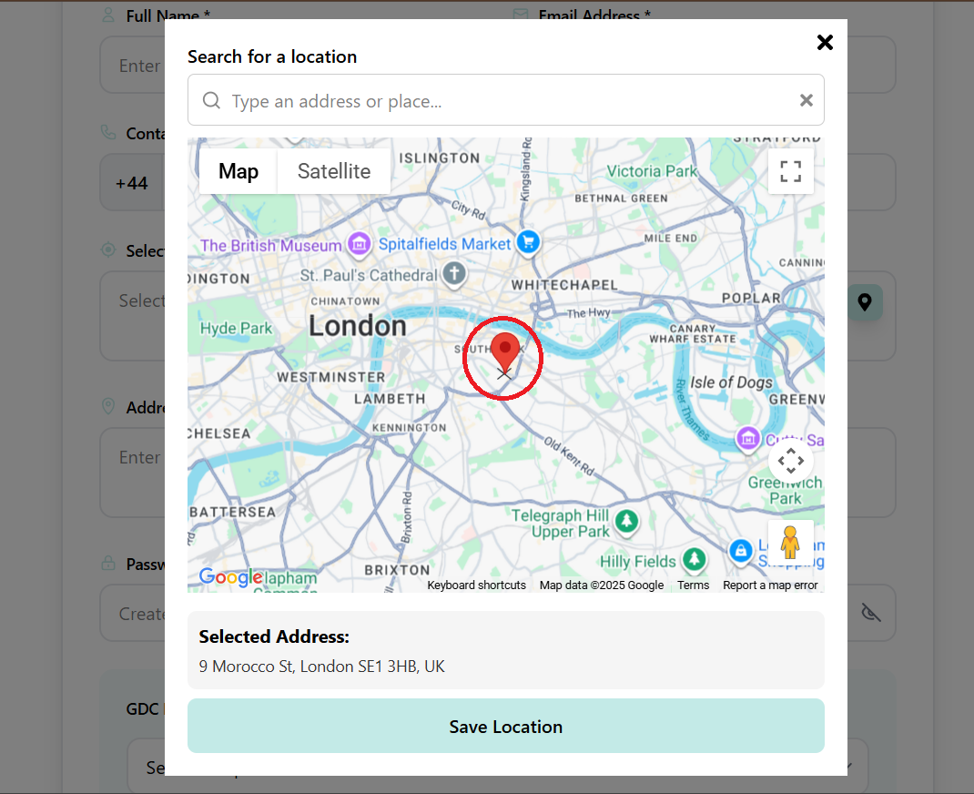
- Search for your location or click on the map to pinpoint your address
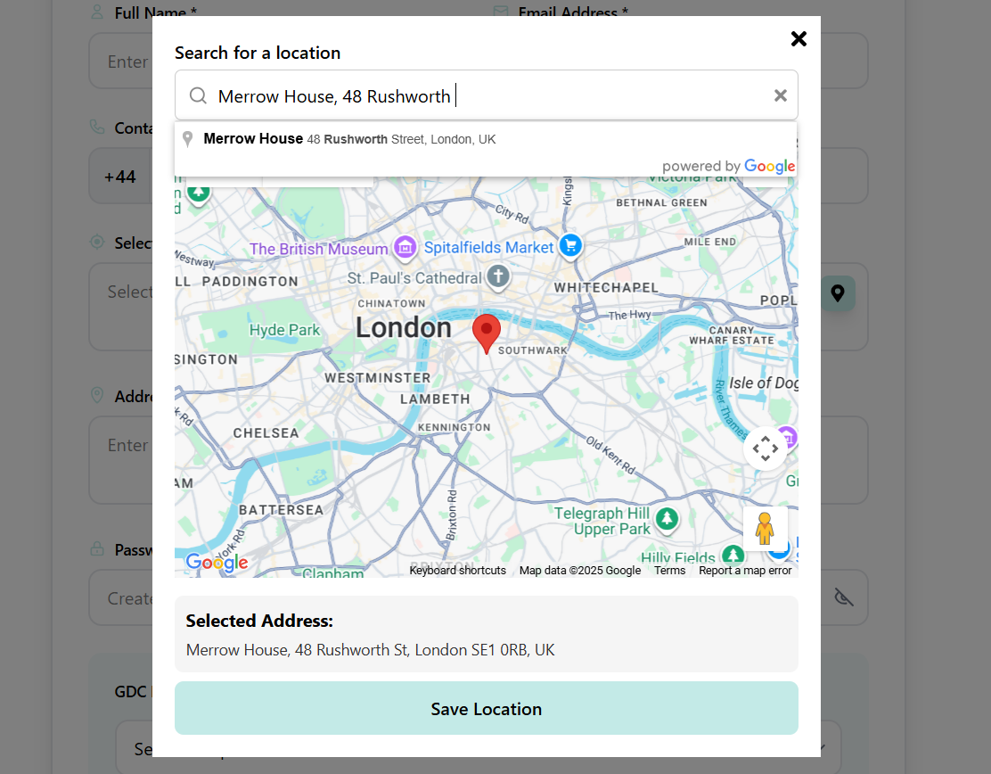
- Confirm the selected location and hit the Save Location button
- The Address field will auto-populate with your chosen location
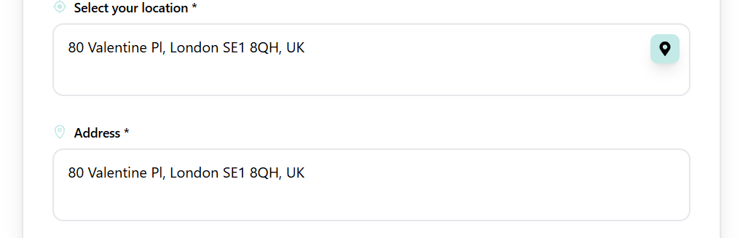

Password: Create a strong password (minimum 6 characters)
The password must include at least one uppercase letter, one lowercase letter, one number, and one special character.

Confirm Password: Re-enter the same password to confirm
Click the eye icon to show or hide the password you have entered

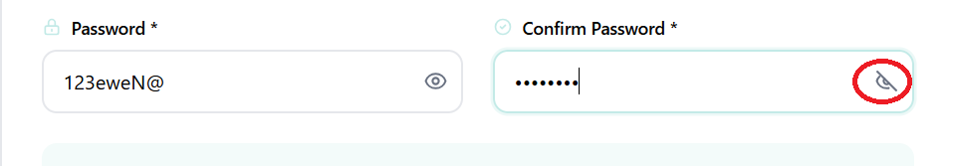

GDC Registration:
Select Yes or No from the dropdown menu.
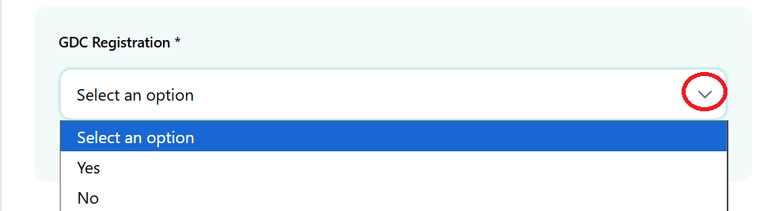
GDC Registration Number:
Enter your official GDC registration number (required if GDC Registration = Yes).
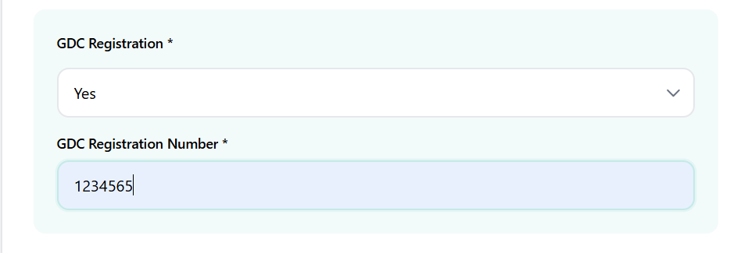

Step 3: Professional Information

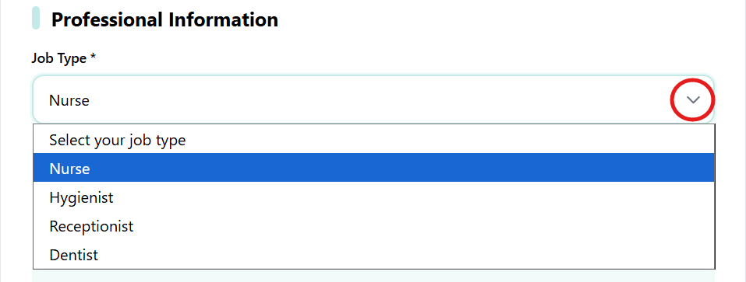

Choose the option that best describes your professional role from the dropdown menu (Nurse, Hygienist, Receptionist, or Dentist).

After selecting your Job Type, you can indicate your relevant professional experience by ticking the appropriate options.
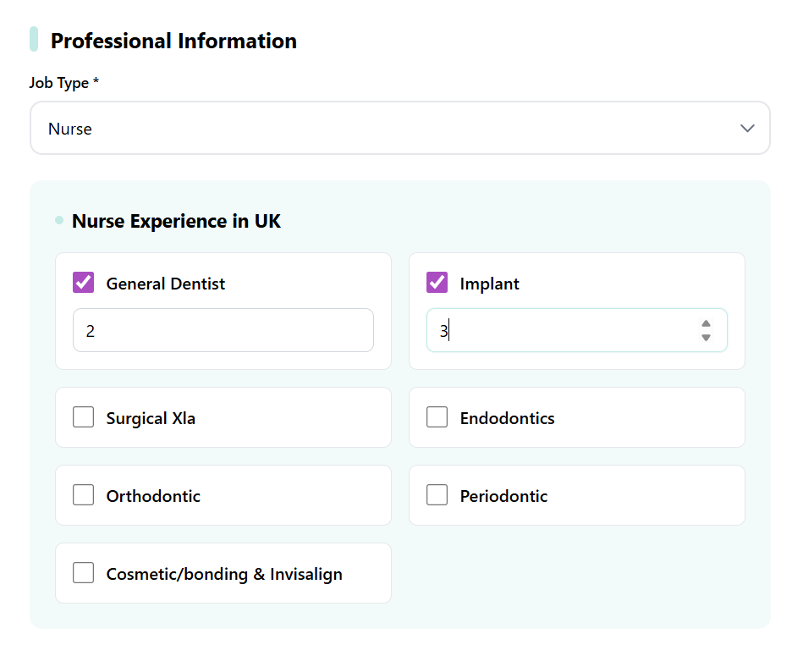
Example:
- If you select Nurse, you may tick any relevant areas:
  - General Dentist
  - Implant
  - Surgical XLA
  - Endodontics
  - Orthodontics
  - Periodontics
  - Cosmetic/Bonding & Invisalign
Entering Years of Experience:
Each section has a field to enter the number of years. You can increase or decrease the value using the small up/down arrows.
Note: Filling this section is optional.


Tick the “I’m not a robot” checkbox to verify that you are a human user before proceeding.


After filling in all required fields and completing the verification, click the Complete Registration button to submit your details.

Click on the bold links to review the Terms and Conditions and Privacy Policy before completing your registration.

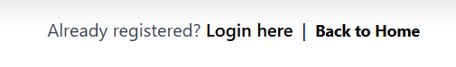
Already registered? Click Login here to access your account.
Click Back to Home to return to the homepage.
Note: The text “Login here” and “Back to Home” are usually displayed as clickable links in the registration form.

